ORION ASTROLOGY WEBSITE

Web Development 1 (Course #420-DW1-ID)

Presented to

Mr. Yves Desharnais

By:

Tatiana Barbosa Guimaraes (653-248401)

Department of Technology

CDI College

November 3rd 2020

*TABLE OF* *CONTENTS*

INTRODUCTION…………………………………………………………………………………………2

1. ABOUT THE CLIENT – ORION ASTROLOGY…......................................................................3
2. DEVELOPING THE WEBSITE………………………………………………………………….4

CONCLUSION…….…………………………………………………………….…………………………5

APPENDICES...………...……………………………………………………….…………………………6

BIBLIOGRAPHY…...…...………………………………….………………………….………………….7

*INTRODUCTION*

My name is Tatiana Guimaraes and I am taking a Programmer Analyst/Internet Solutions Developer program at CDI College. I am currently taking a course called Web Development I, in which I was supposed to make a project as an assessment. My job was to develop a website for an alias client called the Orion Astrology.

Here, I’m supposed to pretend I just started my own website development company and Orion Astrology is my first contract. I need to build a website in order to promote the business and make it accessible to more clients.

I had one week to finish this project, using most of the knowledge and techniques I have learned so far with html and css tools for developing websites. Together with some design and links, I finally finished the project successfully.

*ABOUT THE CLIENT – ORION ASTROLOGY*

Orion Astrology is an alias business created for this project. Its owner, whose name I made up to be Natasha Jenkins, is a lady who runs this small business from home. She offers card readings (tarot) and consultations. She now wants to have a website to try to reach as many people as possible, offering her work and educating about the world of astrology.

I received basic material with the information about astrology, horoscopes and zodiac signs to design and develop her website following her demands. Some sign characteristics and traits, sign images and her contact so people can come in contact with her. I can also add more information if I think is necessary.

*DEVELOPING THE WEBSITE*

For the Orion Astrology website, I first created the design plan with the help of Visio. Then, I wrote on paper the information each section would have. With html code, I created the html files for each page necessary to link to the main page. Then I built their contents following the layout I had drawn before, with navigations bars and a menu. I added the images, lists, forms, tags and text necessary together with some links to other useful documents and websites.

When the layout was done, I used CSS to style the html body. I decided that I wanted a color that had to do with mystic and also wanted it to be a feminine color, so I chose purple. With that, I started chose background, font and border colors. I arranged the aligning of the titles and paragraphs, centered images and added paddings and margins. I also created a new Logo with my knowledge of CorelDraw for the company.

On the main index page, I divided the body with a header containing the logo I created, a title, a list of the business’ services (with anchors to its aside links) and a form for users to subscribe their information. In the main section I added a navigation menu with zodiac signs and dates with links to their daily horoscopes. A brief introduction about Orion Astrology, links to characteristics and traits, a message form for doubts and an aside space with external links to various webpages on astrology, tarot and other services. Finally, in the footer section I added zodiac sign icons with the same links as the navigation menu, some useful links, the logo, the owner contact e-mail and the last update date with the website’s responsible and the business copyright notice.

The links for the characteristics and traits can be found in every single page entered and take the user to a table of information for each zodiac sign.

*CONCLUSION*

In my opinion, the final result of Orion Astrology’s website was very satisfying. I created a simple, yet organized and easy to navigate experience with the knowledge I have. Users will be able to explore the site easily for general information.

I had some difficulties with fonts and links, but as I searched the net and consulted my school material, I could easily conclude my work. I also made sure the website was successfully viewed in all possible browsers. I hope the client will be satisfied.

*APPENDICES*

*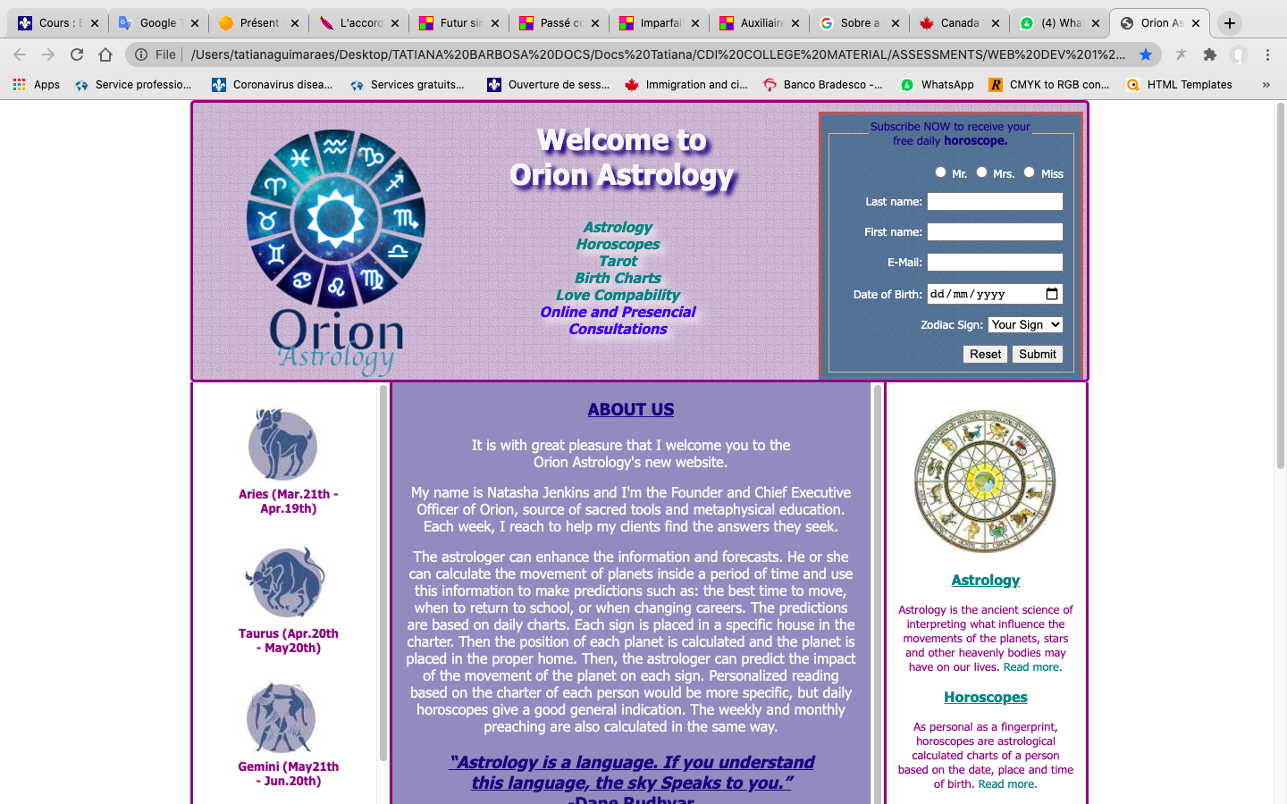*

*BIBLIOGRAPHY*

<https://www.astrologyzone.com/learn-astrology/>

<https://www.astrology.com/us/home.aspx>

<https://www.horoscope.com/us/index.aspx>

<https://www.sagegoddess.com/what-is-tarot/>

<https://www.astro.com/index.htm>

http://nuclear.ucdavis.edu/~rpicha/personal/astrology/